Accumulation Methods

Exposure Available | Shape Analysis | AIR/RMS | Exposed Limit | Draw Shape | Industry Loss
Location Level | ✅ | ✅ | ✅ | ✅ | ⚠️
ZIP Level | ⚠️ | ⚠️ | ✅ | ⚠️ | ✅
County Level | ⚠️ | ⚠️ | ✅ | ⚠️ | ✅
State Level | ❌ | ❌ | ✅ | ❌ | ✅
Portfolio TIV Only | ❌ | ❌ | ❌ | ❌ | ✅
No Exposure | ❌ | ❌ | ❌ | ❌ | ✅

S. No. | Method | Best Use Case | Required Inputs | Optional Inputs | Exposure Type Supported | Processing | Outputs
1 | Track Matching | Event just occurred | Event Name, Event Date | Event ID | All | Match against Event DB/YELT | Existing Event Found/Not Found
2 | AIR/RMS Event Set | Vendor event available within 24-48 hrs | AIR/RMS Event Set | Exposure Filters | Detailed | Run vendor footprint | Gross Loss, Net Loss, AAL Impact
3 | Shape Analysis | Footprint available | Shapefile + DR | Custom DR | Detailed | Polygon Intersection | Loss by Location
4 | Exposed Limit Analysis | Aggregated exposure | ZIP/County/State Exposure | DR File | Aggregate | Political Mapping | Loss by Region
5 | Draw Shape Analysis | Emergency manual analysis | User Drawn Polygon | DR | Detailed | Shape Overlay | Exposure + Loss
6 | Industry Loss Approach | No exposure details available | Industry Loss Estimate | Market Share | No Exposure | Scaling Method | Portfolio Loss Estimate
7 | Hybrid Method | Multiple data sources | Shape + Industry Loss | AIR/RMS | Any | Weighted Approach | Range of Loss Estimates

- In Concentration/Ring analysis:
Why?
What?
Analysis name > selecting Ring (radius) > selecting exposure (have info like location ID, Lat Long, TIV) > converting exposure to point layer shapefile > Damage ratio file > output
For Damage Ratio-
With respect to radius whether it’s based on miles, feet, m, or km, we will be using Damage ratio file. Eg.,
Radius (Feet) | Damage Ratio
3580 | 60
5061 | 80
4560 | 40
8210 | 50

Radius (Meter) | Damage Ratio
1000 | 60
2000 | 80
3000 | 40
4000 | 50

Radius (Km) | Damage Ratio
1 | 60
5 | 80
10 | 40
20 | 50

Radius (Miles) | Damage Ratio
0.5697 | 60
1.5698 | 80
5.5687 | 40
8.4569 | 50

Process:
- While selecting the ring as polygon shapefile and we have point layer shapefile of exposure, we will intersect them and we will get all exposure inside that circle like-
- @locationID1 will have now distance from centre i.e. 0.5 km along with the TIV and locationID2 with 4.2 km with TIV, whereas locationID3 is outside of circle.
- Then we will apply the DR separately on locationID1 and 2 not 3. Loss will be calculated separately on location level for 1 & 2 and then added
- This will give us loss in the circle/ring

- In Draw/ Ad-hoc analysis-
Analysis name > selecting shape (can draw shapes like- circle, square, rectangle, polygon, Line band etc. ) > selecting exposure (have info like location ID, Lat Long, TIV) > converting exposure to point layer shapefile > Damage ratio file > output
For Damage Ratio-
Shape Name | DR (%)
Circle | 40
Rectangle | 50
Square | 60
Polygon | 70

or
Severity | DR (%)
Low | 20
Medium | 50
High | 70
Extreme | 80
Total Loss | 100

Process:
- Selecting shape over the exposure then converting the point layer.
- Inside shape for eg if im taking circle, ill further select medium severity because its not that close and far from the hurricane prone area
- DR will be applied @ location level, giving loss as output.
- Exposed Limit Analysis-
Add the analysis name > Select the exposed limit file (Political Boundaries like pin code, county, State, Area, Country etc.) > Select the DR file > Output Loss
Exposed Limit DR file-
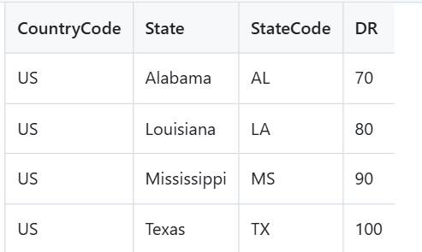
- If we select Texas then, our exposure layer (locationID with Texas) will intersect with Political boundary which will give me exposed limit
- Damage Ratio of 100 will be applied to get Loss
We can also use DR files based on the Peril or severity for exposed limit. For e.g., Florida- Miami Dade- Hurricane can have damage ratio of 100 and New York Suffolk can have 50%.
------------------------------------------------------------------------------------------------------------------
- Exporting data
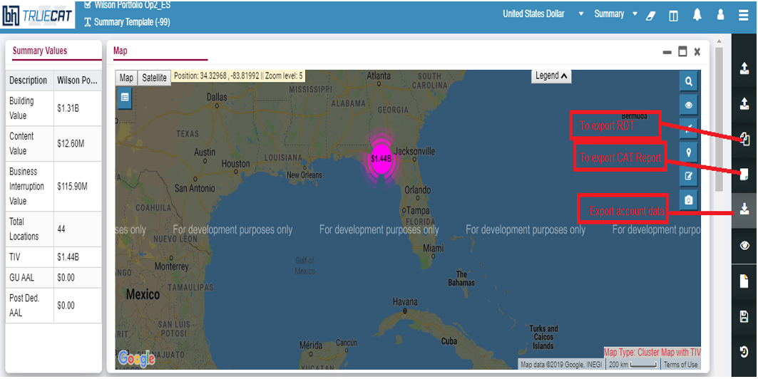

3rd Method- Exposed limit: political boundary DR
- Create exposed limit file i.e. input - .csv upload with File Name, Region Name, Country Code, State Code, County Name, Postal Code
- Create DR file (based on the exposure concentration)
- Submit Exposed Limit Analysis – show in activity monitor
- Output grid — EventID breakdown with GU loss, Gross loss per zone
Why?
Sometimes we don’t need footprint precision. All we need to know is how much of my portfolio is concentrated in Florida, or in a specific zip code cluster, or in a coastal county and what is my maximum possible loss in that zone? Exposed limit exists for accumulation monitoring and limit management. We use it when the question is about concentration and maximum amount rather than event-specific damage.
Input Parameters and Possible Sources:
Input | Source
Country / state / county / zip boundary definitions | US Census Bureau TIGER/Line shapefiles, international boundaries from GADM (gadm.org)
Exposed limit file (manual or CSV) | Will be created internal accumulation zone definitions
Damage ratio file | Available internally
Portfolio exposure — state/zip/county level | Available internally

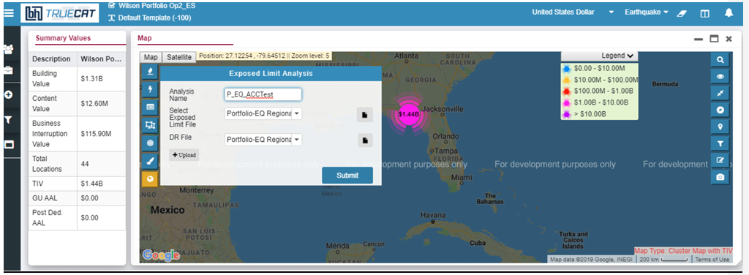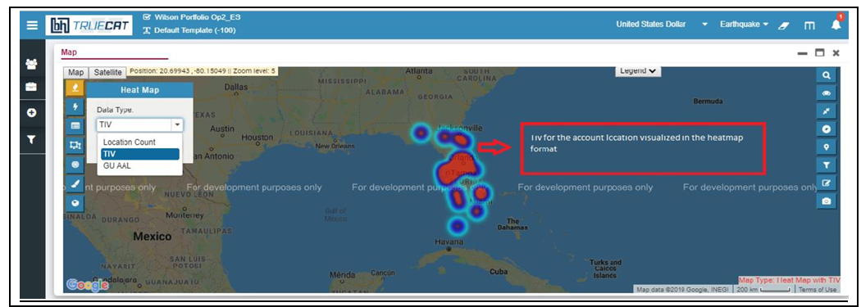
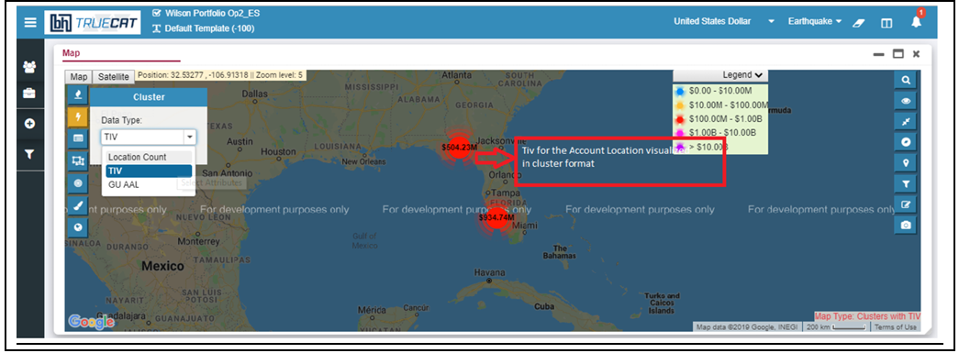
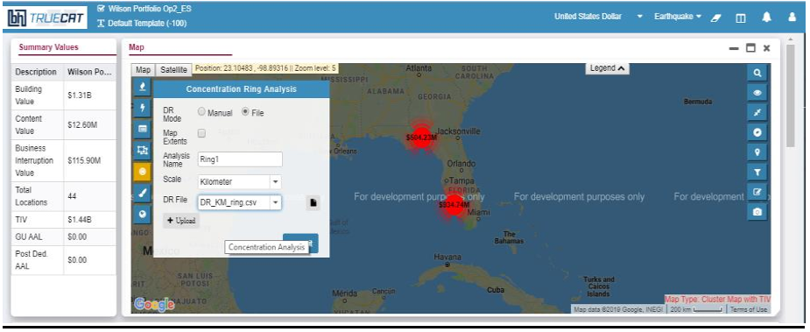
4th Method- 48-hour event set: shared by AIR / RMS
- Vender event set — AIR/RMS delivers stochastic or deterministic event set within 48 hours of real event; format: shapefile or YELT/EDM
- Apply standard DR
- Submit and compare– show in activity monitor
Why?
After a major event, AIR and RMS race to publish a rapid event set within 48 hours- a deterministic model run specifically calibrated to the event as it occurred. This is more precise than track matching (which uses catalogue similarities) and more timely than the final validated footprint (which comes later). The 48hr event set method exists because the first 48 hours after an event are when reserving decisions, reinsurance notifications, and management escalations all happen simultaneously. We need the best available number fast. We use it the moment the vendor delivers the rapid set.
Input Parameters and possible sources:
Input | Source
AIR/RMS rapid event set (within 48hrs) | AIR/RMS Event Response service
Damage ratio file | Available internally
Portfolio exposure file | Available internally

5th Method- Ad-hoc draw
- Draw shape on map- draws polygon over locations on map.
- Mode selection- enter DR value, File mode: upload DR CSV with shape ID and ratio
- Submit Analysis- show in activity monitor
- Output- map shows drawn shapes with losses
Why?
Sometimes an analyst or underwriter wants to ask a question that no vendor file answers. What is my exposure within 30km of the landfall point? What if the storm had tracked 50 miles further north? Ad-hoc draw exists because real events raise hypothetical and sensitivity questions that go beyond what any pre-bundled file can answer. We use it for what-if analysis, PML zone testing, or any scenario where the analyst defines the zone themselves.
Input Parameters and possible sources:
Input | Source
Drawn shape/polygon/ Ring center point and radius | Can use AOI in Circle/polygon or center point may be taken from NHC landfall coordinates or USGS epicenter
Damage ratio | Available internally
Portfolio exposure file | Available internally
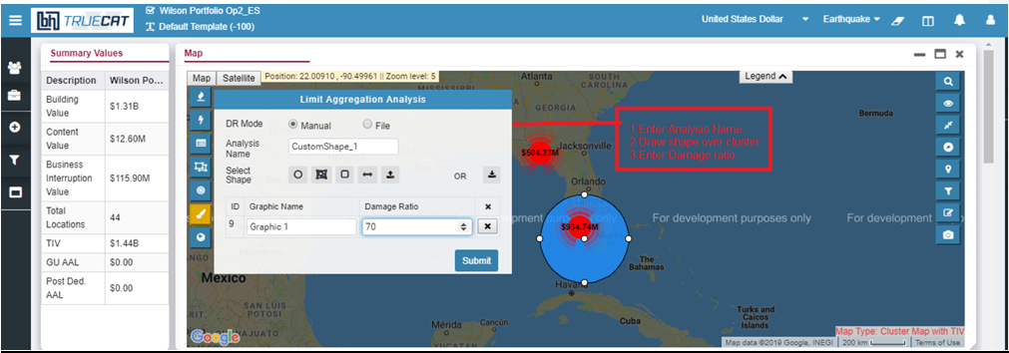
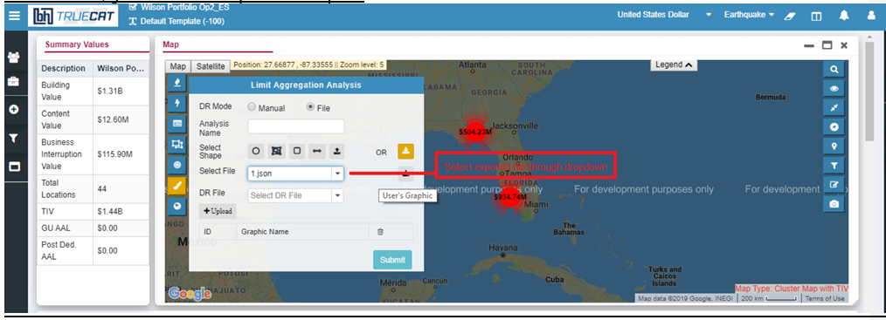
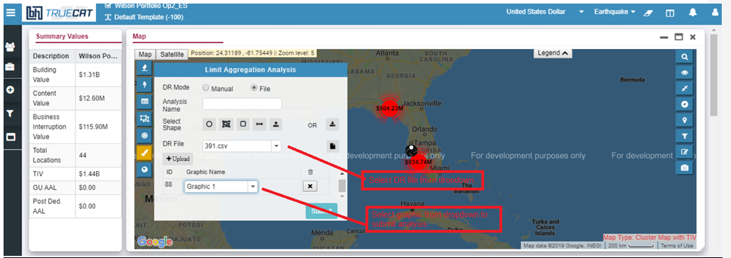
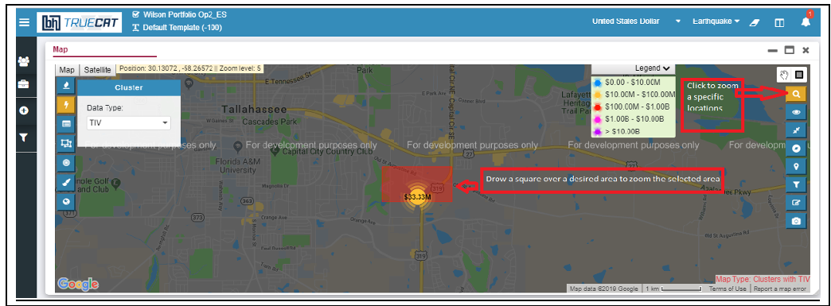

6th Method- Industry loss-based approach
a. Event classification and trigger — confirm the peril has no usable geographic footprint (winter storm, freeze, drought, heat wave); record affected state(s), declared industry loss range, and event dates from PCS / Verisk / government announcement.
b. AIR stochastic catalogue query — fire parameterized query: filter by StateCode, AIR model code (e.g. 28 = US winter storm), and Texas industry loss within the declared range ($2B–$5B); join AIR event info table to pull EventID, description, and year.
c. EDA — exploratory data analysis — review matched event set (e.g. 72 rows); identify loss band distribution (~50 events $2–3B with low US contribution; fewer events $3–5B with outsized national impact); flag high-contribution outliers for priority processing.
d. Per-portfolio loss via Analyze Re — feed selected EventIDs with TX industry loss, US industry loss, and event description into Analyze Re; calculate per-deal loss for Fund 1 and Fund 2; for quota share deals output shows exact proportional risk each deal carries in the affected state.
e. Output and reporting — aggregate per-deal losses across funds; produce best / mid / worst case scenarios across the declared loss range;
Export EDA Excel, CAT report, and deal-level quota share breakdown; flag highest-exposure deals for underwriter review.
Why?
Some perils- winter storm, freeze, drought, heat wave do not produce a geographic footprint. The hazard is a prolonged atmospheric condition spread across a large area with no clear boundary. The only usable signal is the industry loss estimate published by PCS, Verisk, or a government body. Loss-based approach exists because for these perils, working backwards from a loss number through the AIR catalogue is the only rigorous way to estimate your portfolio impact. We use it when the peril is diffuse and the industry loss estimate is the best available data point.
Input parameters and possible sources:
Input | Source
Declared industry loss range | PCS (Property Claim Services), Verisk Extreme Event Solutions/ Industry Loss database, Swiss Re sigma estimates, Munich Re NatCatSERVICE
Affected state(s) | Event news, FEMA disaster declaration (fema.gov/disaster), NWS storm summaries for winter storm / freeze events
AIR model code | Available internally
AIR stochastic catalogue — event loss table | Available internally
AIR event info table | AIR Touchstone database
Line of business scope | Available internally

Appendix:
TrueCAT exposed limit UI pictures:

-----------------------------------------------------------------------------------------------------------------
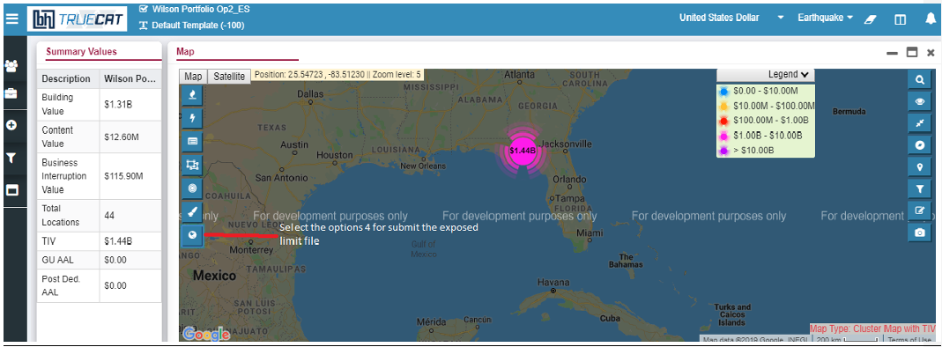
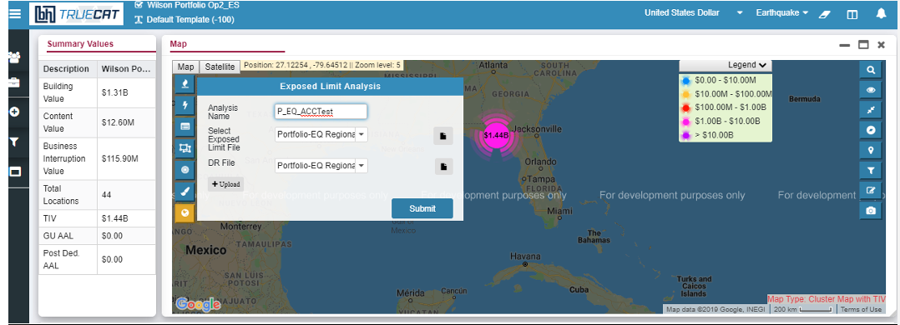
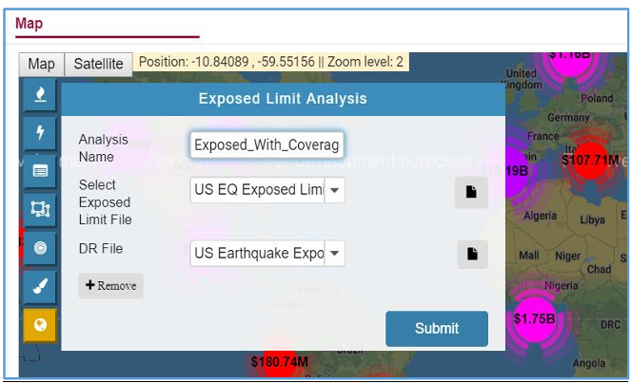
If file contains multiple event IDs of exposed zones, TrueCAT will calculate the losses for each zone independently.
Exposed limit File:
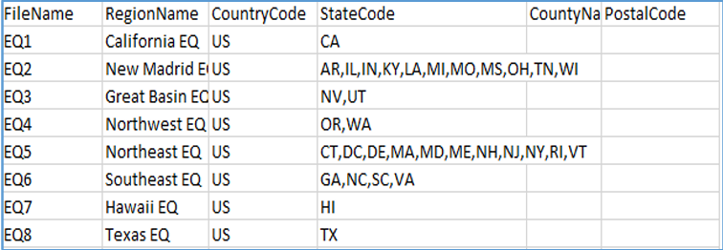
Ad-hoc analysis:

-----------------------------------------------------------------------------------------------------------------
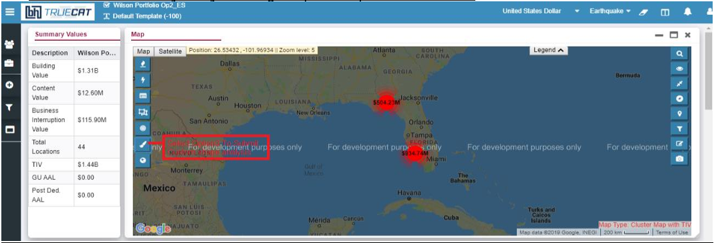
To submit custom shape analysis, please follow below steps: Draw shape over cluster Enter damage ratio
This can also be done manually
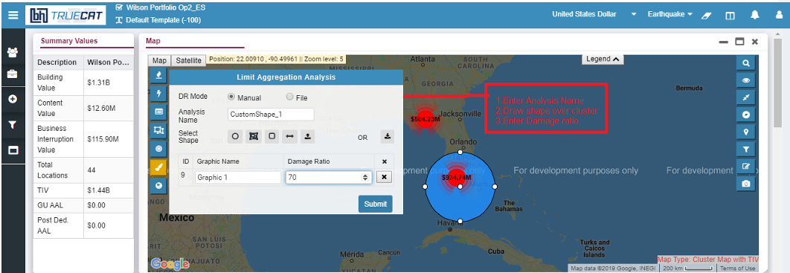 and in file mode.
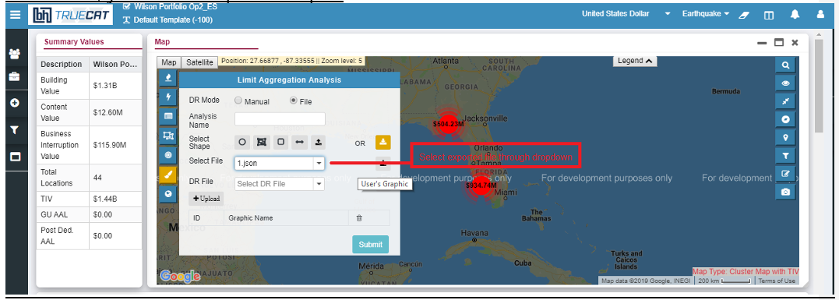
Once you import shapes over map visualization, Shapes will display on map. Now next step is to select damage ratio file and graphics to submit analysis.
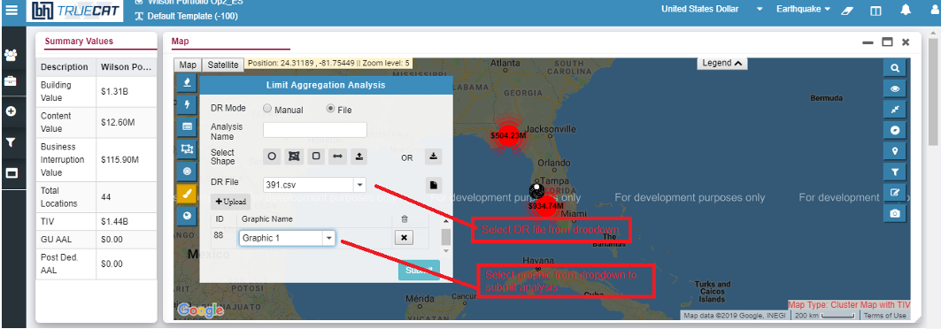
------------------------------------------------------------------------------------------------------------------
Concentration/ ring analysis:
------------------------------------------------------------------------------------------------------------------
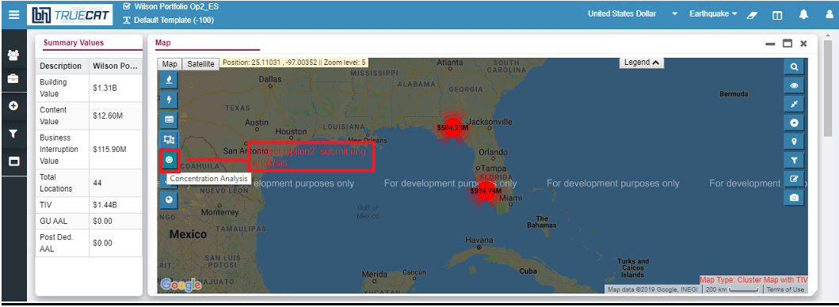
This can be done manually or by file. In manual-
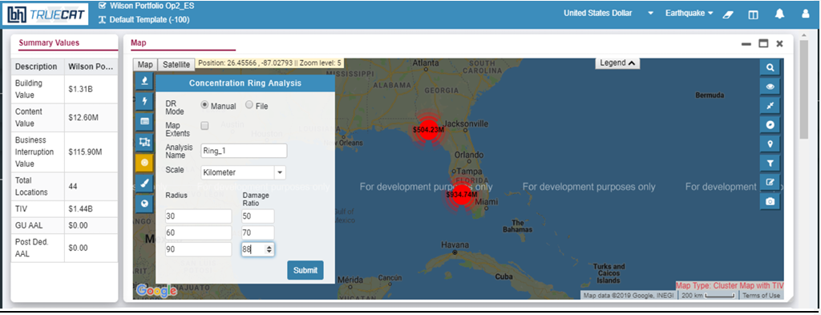
In file mode-
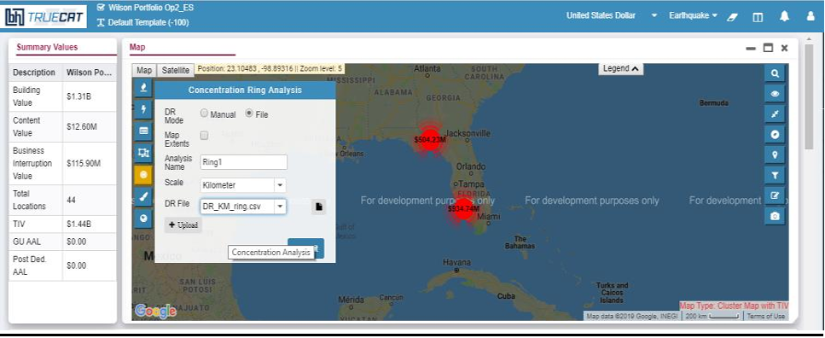
Tip: In file mode user need to upload DR file with Radius and damage ratio. To preview DR file, click on from same pop-up window.
------------------------------------------------------------------------------------------------------------------

